**MATLAB PROB 4:**

**Without error:**

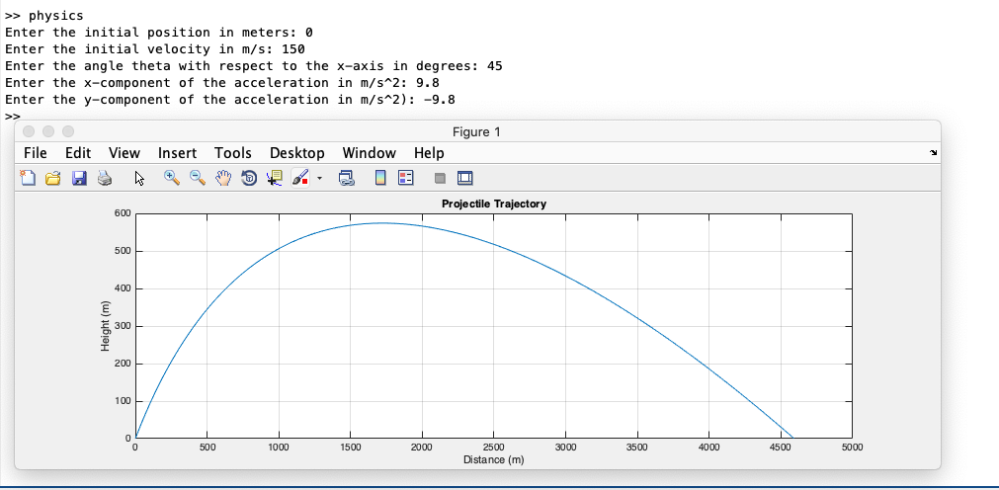

**With error (y-component or acceleration is greater than or equal to zero):**

